**Assignment 2A**

1.

a. Display the current time in 12-hour format.

b. With a user-specified date, display only the day of the week (e.g. Tuesday).

2. Write the command to find the square root of 4.

3. Show how we can calculate the following expression in the terminal of UNIX

A=5, b=6,z=15

Total = (A*b) + (z/A)

Display the Total.

4. How can we sort a list of numbers in a file (both ascending and descending order)?

5. Create the file student.dat as follows:

Roll | Name | Dept | Year

105 | Anik | CSE | 1st

101 | Debesh | CSE | 2nd

108 | Aniket | IT | 1st

200 | Mainak | ECE | 2nd

105 | Anik | CSE | 1st

a. Sort the data according to Roll.

b. Sort the data according to Dept.

c. Show only the records of students from the CSE Dept.

6. Show the last 2 lines of the file animals.txt.

7. Show the first 3 lines of the file animals.txt.

8. (Re-Visit) List only the directory files in your current directory.

9. Count the number of directories in your current directory.

10.

Dog is a domestic animal

Dog hates cat

Cat drinks milk

Dog is bigger than Cat

Cat is also a domestic animal

a. Find the total number of lines contains the word ‘Dog’ in animals.txt.

b. Also find the total number of lines does not contain the word ‘Dog’ in animals.txt.

c. Display the lines in animals.txt that end with the word 'cat'.

Solution:-

1.a.

b.

2.

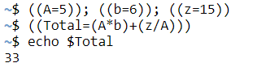3.

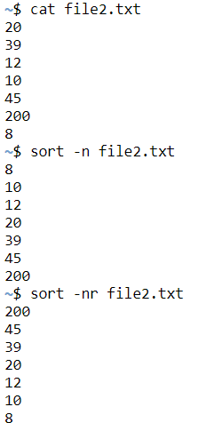4.

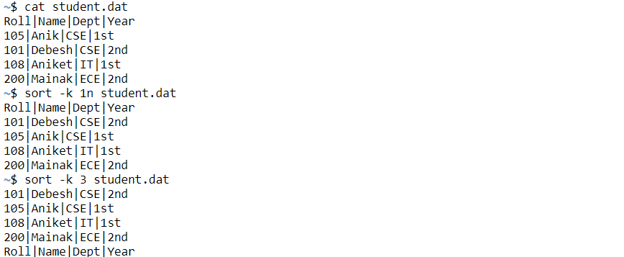5.a,b.

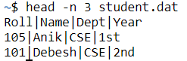c.

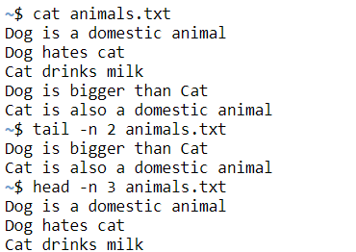6,7.

8,9.

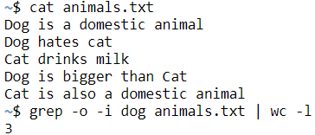10.a.

b.

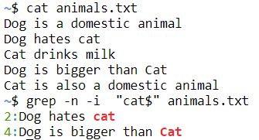c.